Mini Project

Project Title: Income Distribution Analysis by Demographics and Employment
Dataset: Adult (Census Income) Dataset (Adult Test)
Source: UCI Machine Learning Repository
Link: https://archive.ics.uci.edu/dataset/2/adult
Records: 16,281 | Columns: 15 (6 numerical, 9 categorical)
Relevance: Analyses how education, occupation, age, gender,
race and working hours relate to earning above or below $50K.

1. Dataset Selection
Dataset: Adult (Census Income) Dataset .. (Please note that I have used adult test data set from the adult zip file)
Source: UCI Machine Learning Repository, https://archive.ics.uci.edu/dataset/2/adult
Domain: Human demographics and income analysis
File used: adult_test.txt
Why this dataset:
- Relevance: it shows how education, occupation, age, gender, race and working hours relate to earning above or below $50K.
- Size: 16,281 records, well above the 500 minimum.
- Features: 15 columns, above the 10 minimum, mixing 6 numerical columns (Age, Fnlwgt, Education_Num, Capital_Gain, Capital_Loss, Hours_Per_Week) and 9 categorical columns.
- Source: UCI is a recognised, reliable repository listed in the project guidelines.
- Cleaning potential: it contains missing values, duplicates and formatting problems, so it suits a data pre-processing task.
Limitation: the data comes from the 1994 US Census, so the figures describe that period, not current salaries.
2. Data Pre-processing using Excel
2.1 Importing and structuring
- Imported the comma-separated text file using Data > From Text/CSV.
- The first line of the file (|1x3 Cross validator) was not a record, and the file had no header row, so I typed 15 column headers: Age, Workclass, Fnlwgt, Education, Education_Num, Marital_Status, Occupation, Relationship, Race, Sex, Capital_Gain, Capital_Loss, Hours_Per_Week, Native_Country, Income.
2.2 Removing duplicates
- Used Data > Remove Duplicates across all 15 columns.
- Result: 5 duplicate rows removed, leaving 16,276 records.
2.3 Handling missing values
- Missing values were stored as ? in three columns: Workclass (963), Occupation (966) and Native_Country (274). In total, 1,221 rows had at least one missing value.
- Used the column filter to select only the ? rows and replaced them with “Unknown”.
- Reason: deleting those rows would remove about 7.5% of the data and could bias the results, so I labelled them as a category and kept every record.
2.4 Standardizing formats
- Removed leading spaces from the text values.
- Removed the trailing full stop from the Income column (<=50K. became <=50K and >50K. became >50K).
- Checked that numeric columns were stored as numbers and text columns as text.
2.5 Calculated fields
Field | Purpose | Formula
Income_Group | Readable label for charts | =IF(O2=">50K","High Income","Low Income")
Income_Flag | 1 or 0, used to calculate % high income | =IF(O2=">50K",1,0)
Age_Group | Age bands (17-24, 25-34, 35-44, 45-54, 55-64, 65+) | nested IF on Age

2.6 Filtering and sorting
- Filtered by Income_Group to view only high earners.
- Sorted by Age and Hours_Per_Week (largest to smallest) to check the extremes.

2.7 Pivot tables (sheet: Pivot_Analysis)
- Income split: count by Income_Group (High Income 3,846; Low Income 12,430).
- % High Income by Education: average of Income_Flag by Education.
- Income by Occupation: count of people by Occupation and Income_Group.
- Average hours by Sex and Income: average Hours_Per_Week by Sex and Income_Group.
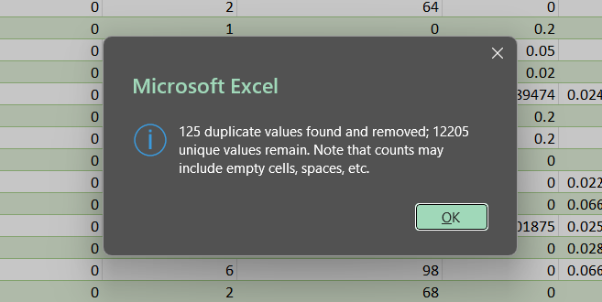
Sort and Filter :
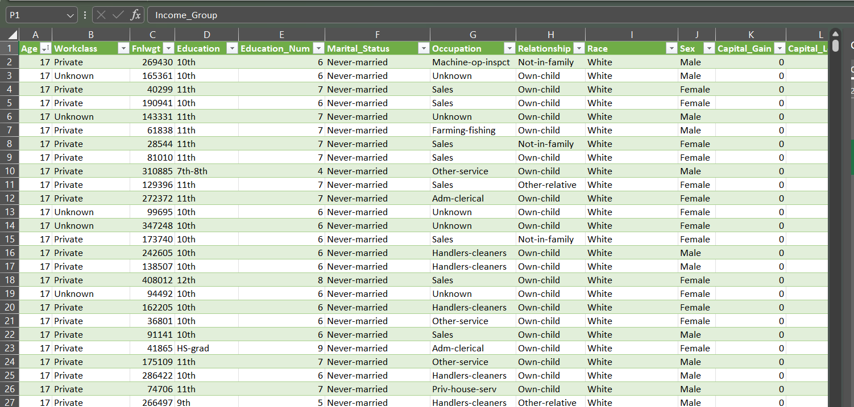
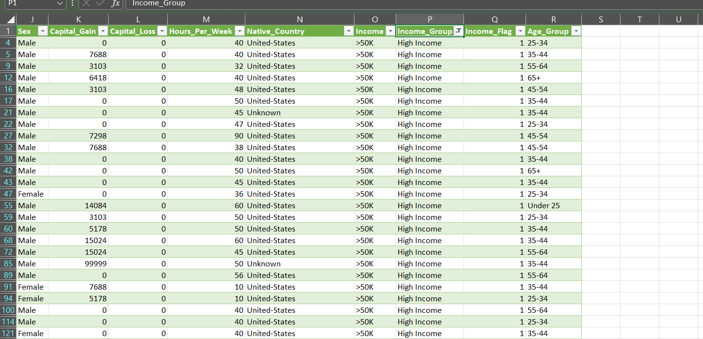

3. Data Visualization using Power BI
3.1 Data loading
- Loaded the Cleaned sheet from Cleaned_Dataset.xlsx and checked column data types in Power Query.
- Confirmed the table contains 16,276 rows.
- Set Education to sort by Education_Num, so it displays from Preschool up to Doctorate.
3.2 DAX measures
Total Records = COUNTROWS(Cleaned_Dataset)
High Income Count = CALCULATE(COUNTROWS(Cleaned_Dataset), Cleaned_Dataset[Income_Flag] = 1)
% High Income = DIVIDE([High Income Count], [Total Records])
Avg Age = AVERAGE(Cleaned_Dataset[Age])
Avg Hours per Week = AVERAGE(Cleaned_Dataset[Hours_Per_Week])
3.3 Page 1: Income Overview
- Cards: Total Records (16,276), % High Income (23.6%), Average Age (38.8), Average Hours per Week (40.4).
- Donut chart: income distribution (23.63% High Income, 76.37% Low Income).
- Bar chart: % earning above $50K by education level.
- Column chart: % earning above $50K by age group.
- List Slicers: Sex, Race and Income_Group, which filter the whole page.

3.4 Page 2: Workforce Details
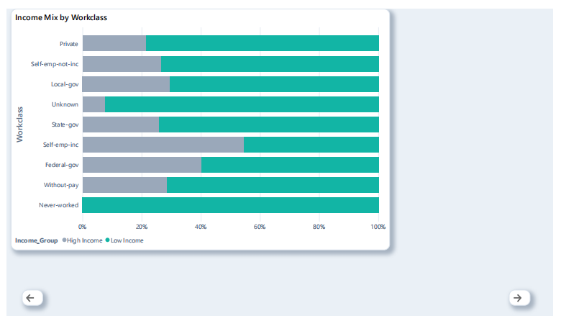
3.5 Design choices
Every chart has a title, axis titles, data labels and a legend where needed, and the slicers are styled the same way.
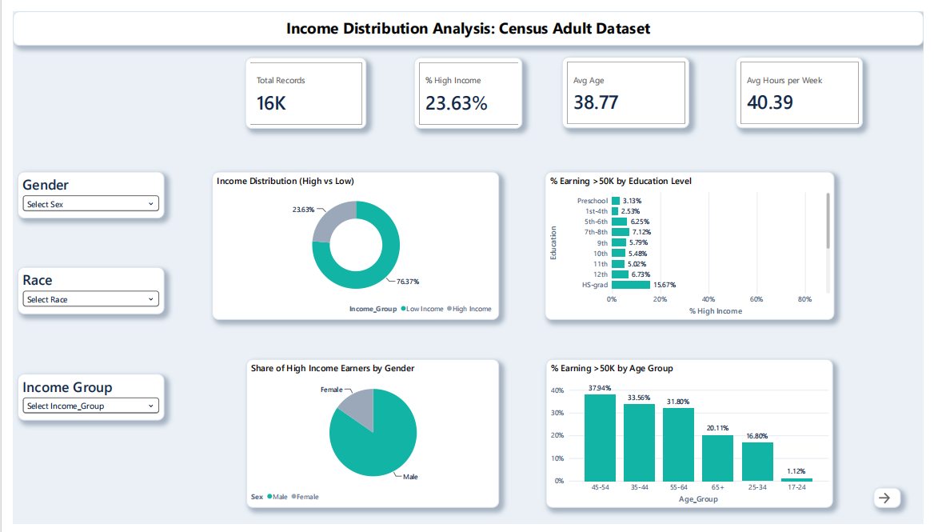

4. Key Insights
- Income split: about 23.6% of people in the dataset earn more than $50K, and 76.4% earn $50K or less.
- Education matters most: Prof-school (75.2%) and Doctorate (69.1%) have the highest share of high earners, compared with 15.7% for HS-grad and about 3% for Preschool.
- Hours: high earners work longer hours. Men average 46.2 hours (high income) and 40.8 hours (low income), and women average 41.2 and 35.8.
- Age: the share of high earners rises with age and peaks in the middle age groups (about 38% for ages 45-54), while the 17-24 group is close to zero.
- Occupation: (add your own finding from the Page 2 chart, such as which occupations have the highest share of high earners).

